The future of Suffolk

Questionnaire on the Suffolk Devolution Deal

Have your say
18 March to 26 May

About this questionnaire

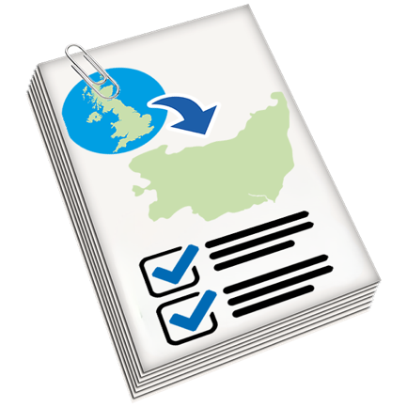 | We will tell you some important things about the Suffolk Devolution Deal.

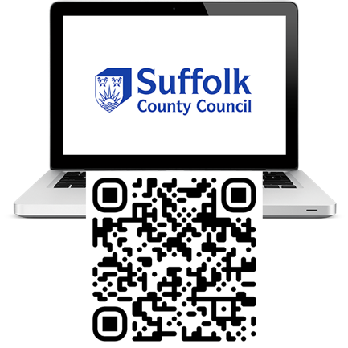 | You can watch a video about the Suffolk Devolution Deal and read more about it at: www.suffolk.gov.uk/devolution

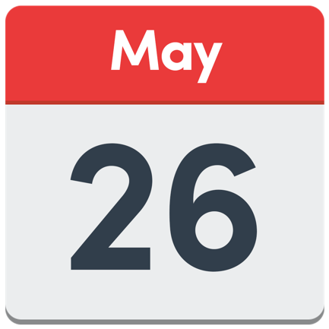 | You have until 26th May 2024 to do this questionnaire.

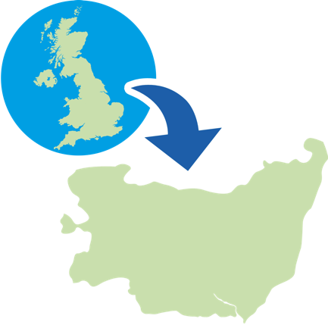 | What is devolution?

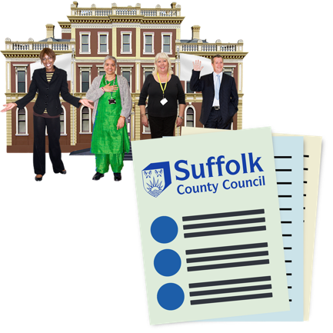 | Suffolk County Council provides public services that cover the whole county, such as:

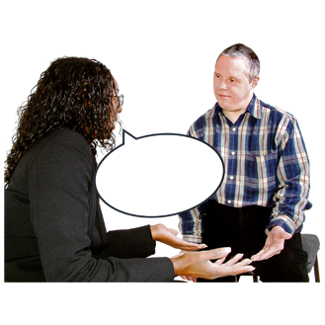  Social care for children and adults | 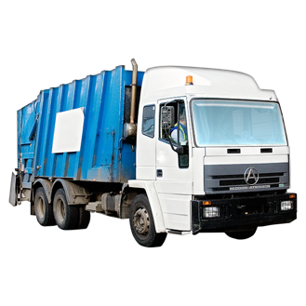  Household waste collection

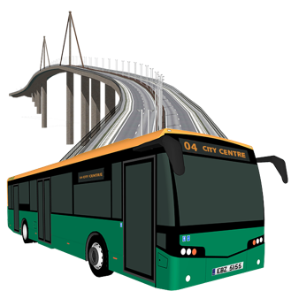  Highways and transport | 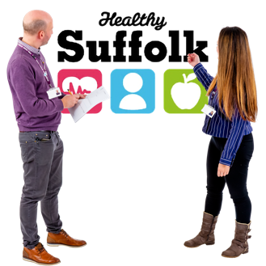  Public health

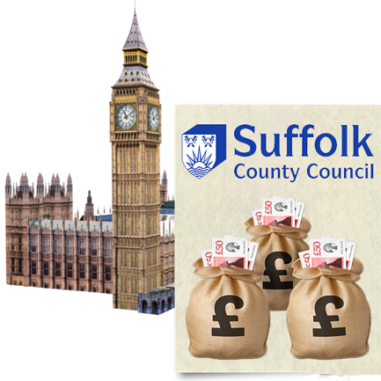 | The government still makes some decisions about how Suffolk County Council spends its money.

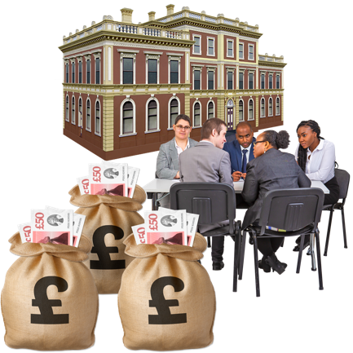 | Devolution means the Government will give more control to Suffolk County Council to decide how it wants to spend money.

This makes sure decisions are made closer to the local people, communities, and businesses they affect.

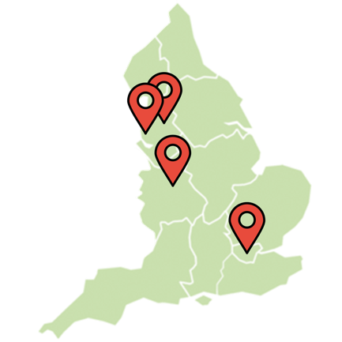 | This has already happened in some other areas, including Greater London, Liverpool, West Midlands and Greater Manchester.

Question 1: Do you think it is a good idea that the government gives Suffolk County Council more control when deciding how to spend money?

Good Idea | Bad Idea | Not Sure

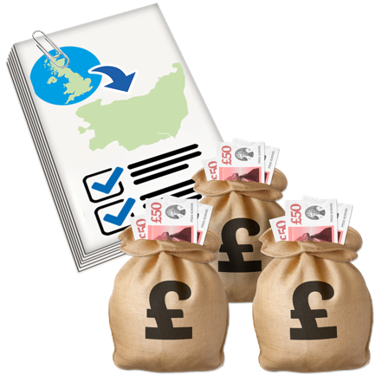 | How much money will Suffolk get from the Devolution Deal?

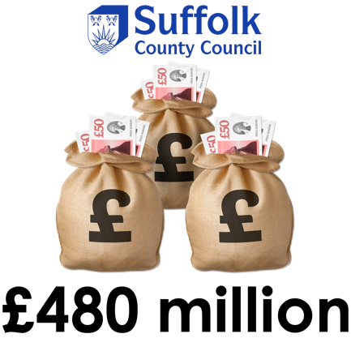 | Under this deal, Suffolk County Council would get £480 million over 30 years.

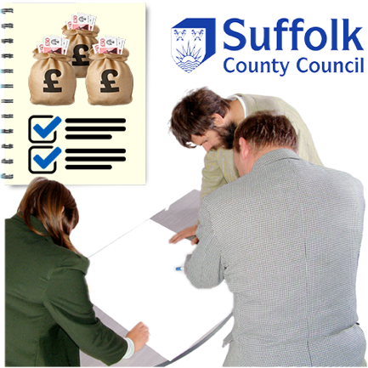 | Suffolk County Council and other organisations would decide how best to use this money.

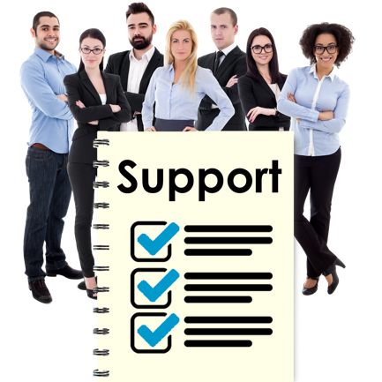 | This could be support to local businesses.

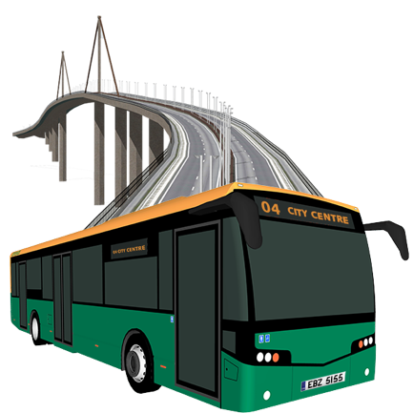 | Or improving roads and public transport.

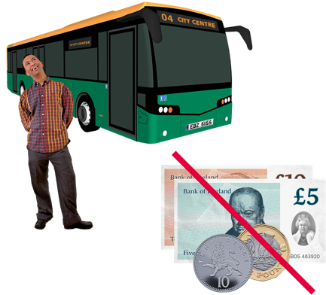 | Or helping people access free bus travel.

Question 2a: How important is it that Suffolk County Council gets control of £480 million to pay for things local people need?

Important | Not important | Don’t know

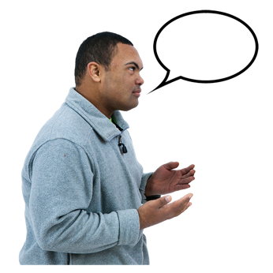 | Please explain your answer

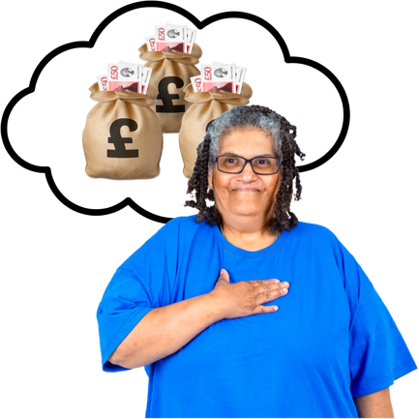 | Question 2b: If the deal were to go through, how would you like Suffolk County Council to spend this £480 million?

Adult Education

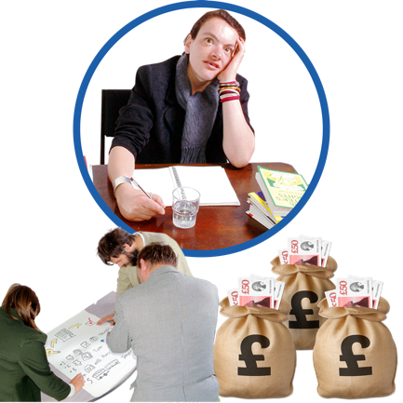 | Under the devolution deal, Suffolk County Council would become responsible for planning and paying for adult education in Suffolk.

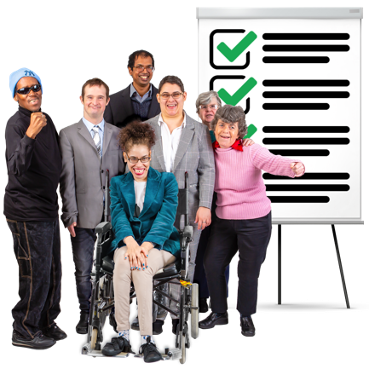 | Adult education is for people aged over 19 years old and includes learning and training courses.

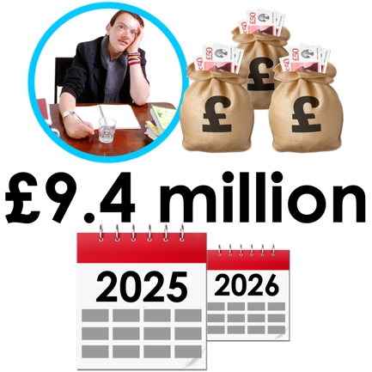 | In 2025/26, the money we expect to get for Adult Education is £9.4 million.

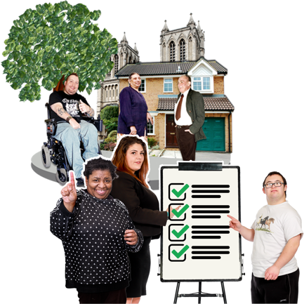 | We would talk to local business and adult education providers to find out what training people need.

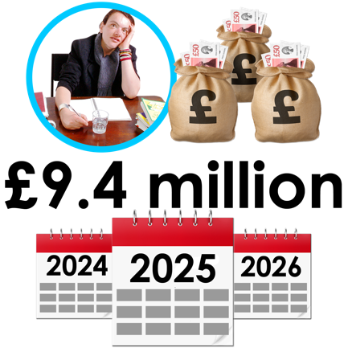 | Question 3: How important is it that Suffolk County Council gets control of £9.4 million a year to plan and pay for adult education in Suffolk?

Important | Not important | Don’t know

Please explain your answer…

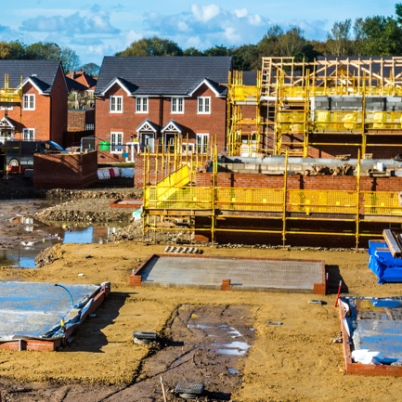 | Building houses

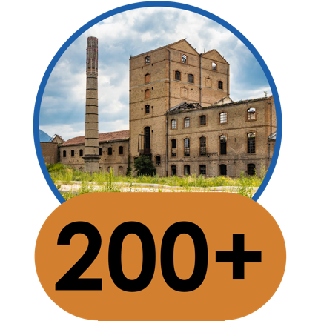 | There are more than 200 brownfield sites that could be built on.

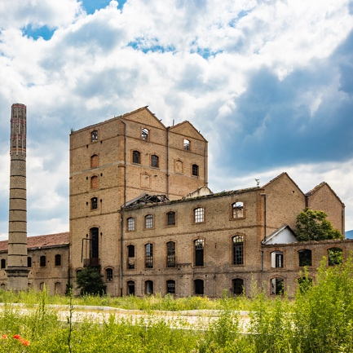 | Brownfield sites are land where there are old buildings which no longer get used.

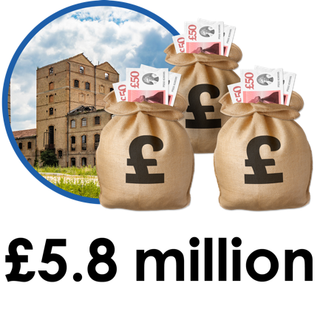 | Under the devolution deal, Suffolk County Council would get £5.8 million to get brownfield sites ready to build on.

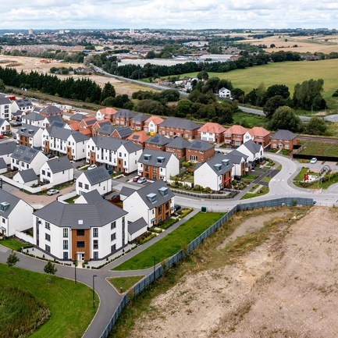 | This would help create the right locations to build more houses.

Question 4: How important is it that Suffolk County Council gets £5.8 million to use brownfield sites for building houses?

Important | Not important | Don’t know

Please explain your answer…

Transport

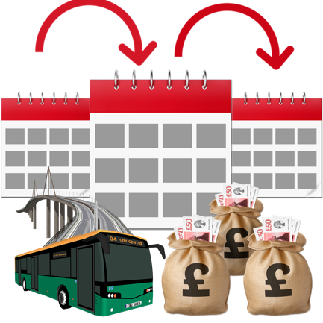 | At the moment, Suffolk County Council gets money for transport from the Government every year.

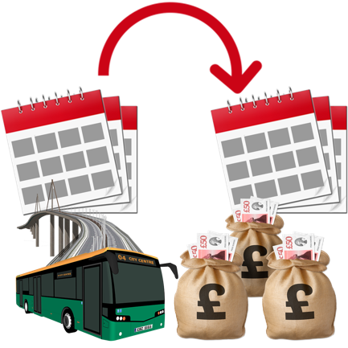 | Under the devolution deal, we would get money over a few years at a time instead.

This means we can plan better for the future.

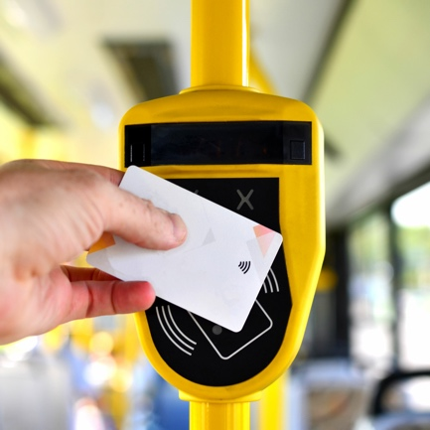 | We could introduce Oyster card-style smart ticketing.

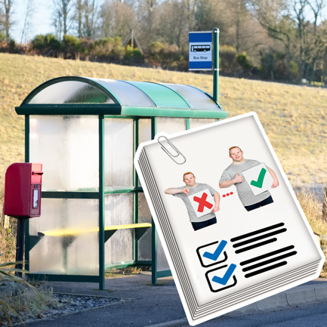 | Or have more buses in rural areas.

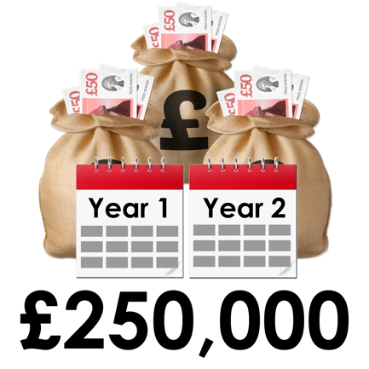 | We would also get £250,000 each year for two years to support the Suffolk’s Local Transport Plan.

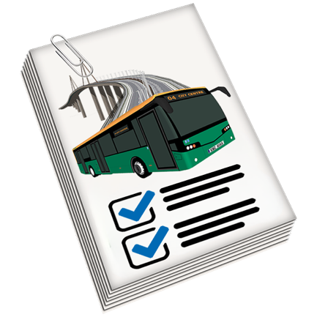 | Suffolk’s Local Transport Plan is a plan for managing and developing transport in Suffolk.

Question 5: How important is it that Suffolk County Council gets money for a few years, rather than every year?

Important | Not important | Don’t know

Please explain your answer

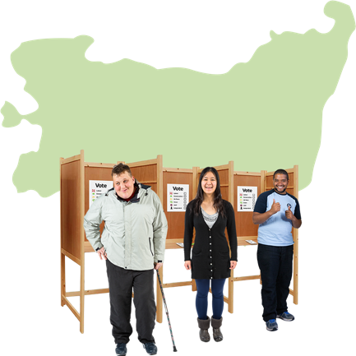 | Local decision-making

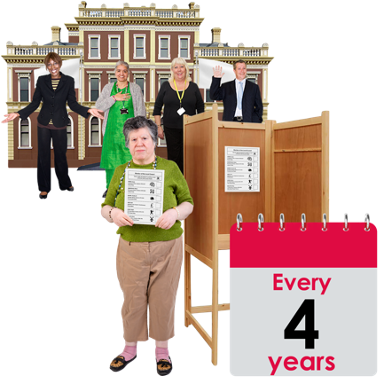 | At the moment, you get to elect your local councillor every 4 years.

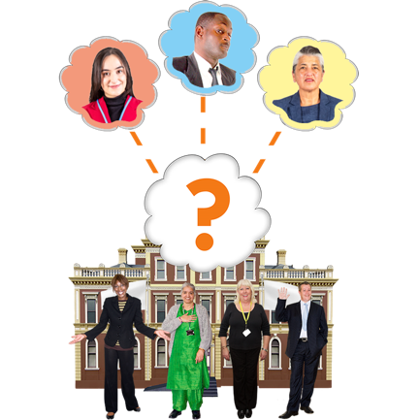 | Then Suffolk County councillors choose the council leader.

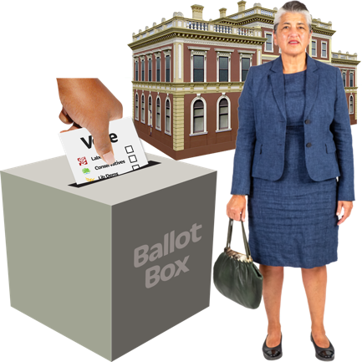 | Under the devolution deal, you would get to vote on who will become the council leader.

The council leader voted in by people can be from any political party or no party at all.

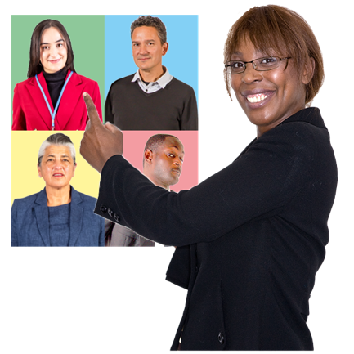 | The council leader voted in by people can chose other councillors to be in their cabinet.

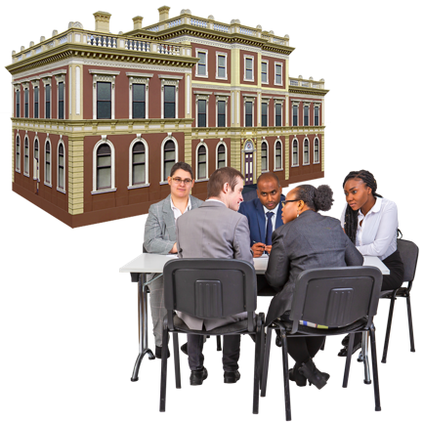 | A cabinet is a group of councillors who make decisions about what a council does.

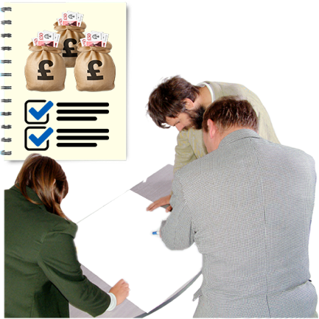 | The council leader voted in by people would need to work with the other councillors to agree on plans and how to spend money.

Question 5: How important is it that you can vote for the Suffolk County Council leader?

Important | Not important | Don’t know

Please explain your answer

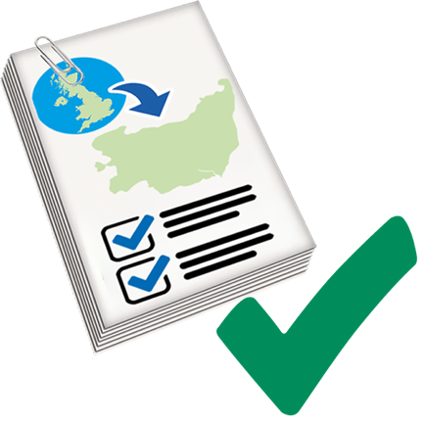 | Question 6: Do you think that Suffolk County Council should accept the devolution deal?

Agree | Disagree | Don’t know

Please explain your answer

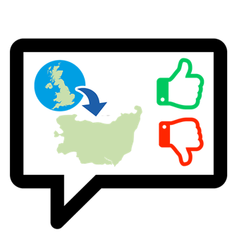 | Question 7: Do you have any other comments about the devolution deal? This includes any good or bad things it will mean for you.

About you

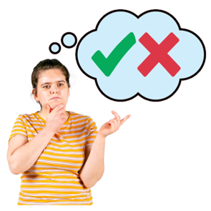 | It is your choice whether to answer these questions or not.

Answering these questions helps us understand who is responding to the consultation.

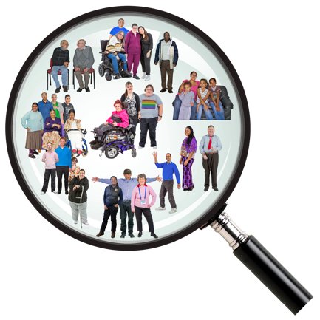 | We can then make extra effort to reach groups of people that are not answering our questionnaires.

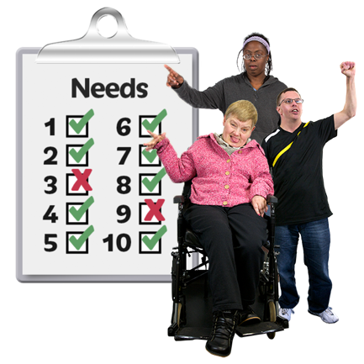 | Answering these questions will help us understand your specific needs.

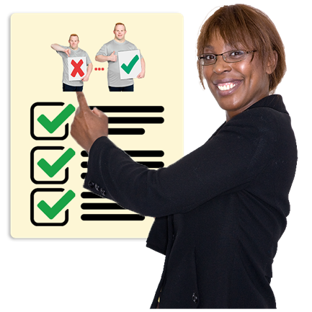 | We can then make changes or improve our questionnaires so more people can fill them in.

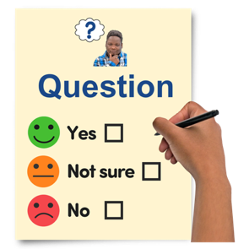 | Question 8: Would you like to answer these questions?
 |  | Yes |  | No

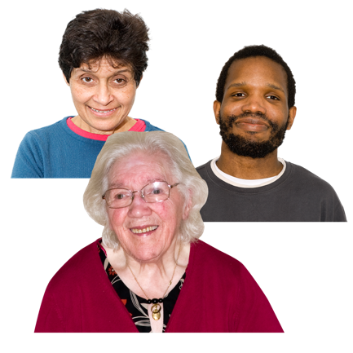 | Question 9: How old are you?  I am

Question 10: Are you…
(Tick one box that applies to you)

Male | 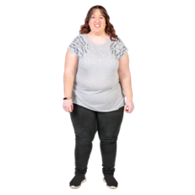  Female | 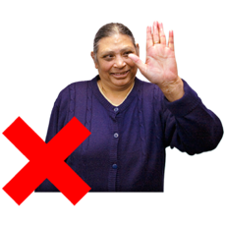  Don’t want to say

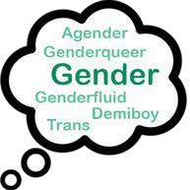 | I use a different word for my gender.  I am

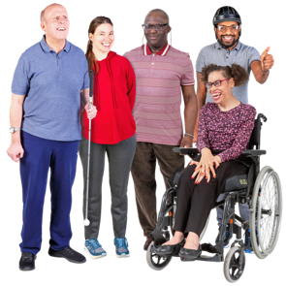 | Question 11: Do you have a long-term health problem or disability that affects how you do daily activities?  (Tick one box that applies to you)

Yes | No | 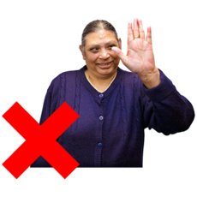  Don’t  want to say

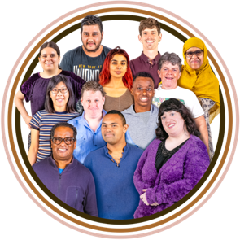 | Question 12: To which of these groups do you consider you belong?  (Tick one box that applies to you)

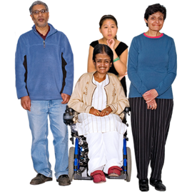 | Asian / Asian British
 | Indian | Pakistani
 | Bangladeshi | Other

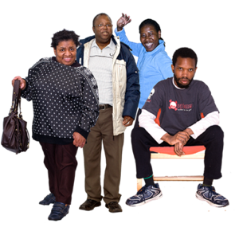 | Black / African / Caribbean / Black British
 | African | Caribbean
 | Other

Chinese

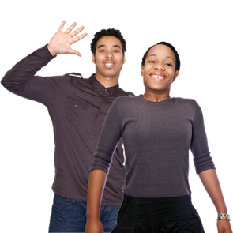 | Mixed
 | White and Black Caribbean | White and Black African
 | White  and Asian | Other

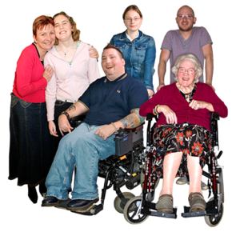 | White
 | English | Irish
 | Scottish | Welsh
 | British | Gypsy or Irish Traveller
 | Other

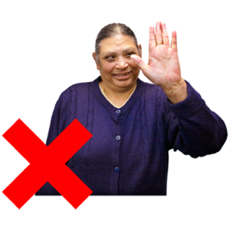 | Don’t want to say

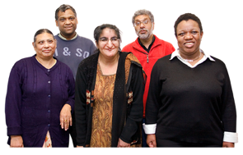 | If you ticked other, please write what background you are from

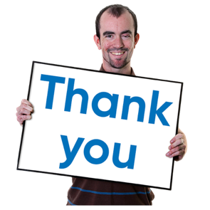 | Thank you for filling in this survey and sharing your views.

To return the questionnaire by post, please send it to:
Communications, Consultation and Media Team
Suffolk County Council
Endeavour House
8 Russell Rd
Ipswich
IP1 2BX

To return the questionnaire by email, please send it to:
devolution@suffolk.gov.uk

This document was translated into easy read by Ace Anglia.

Website: www.aceanglia.com
Facebook: Ace Anglia
Instagram: @ace_anglia
Twitter: @aceanglia
Email: info@aceanglia.com

This document was made in April 2024

